Question 16.1
Refer to the exhibit.
SW1#
Name: Et0/0
Switchport: Enabled
Administrative Node: trunk
Operational Mode: trunk
Administrative Trunking Encapsulation: dot1q
Operational Trunking Encapsulation: dot1q
Negotiation of Trunking: On
Access Mode VLAN: 1 (default)
Trunking Native Mode VLAN: 1 (default)
Administrative Native VLAN tagging: enabled
Voice VLAN: none
Administrative private-vlan host-association: none
Administrative private-vlan mapping: none
Administrative private-vlan trunk native VLAN: none
Administrative private-vlan trunk Native VLAN tagging: enabled
Administrative private-vlan trunk encapsulation: dot1q
Administrative private-vlan trunk normal VLANs: none
Administrative private—vlan trunk associations: none
Administrative private-vlan trunk mappings: none
Operational private-vlan: none
Trunking VLANs Enabled: 1,22
Pruning VLANs Enabled: 2-1001
Capture Mode Disabled
Capture VLANs Allowed: ALL

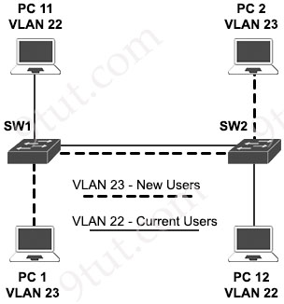
VLAN 23 is being implemented between SW1 and SW2. The command show interface ethernet0/0 switchport has been issued on SW1. Ethernet0/0 on SW1 is the uplink to SW2. Which command when entered on the uplink interface allows PC 1 and PC 2 to communicate without impact to the communication between PC 11 and PC 12?
A. switchport trunk allowed vlan 2-1001
B. switchport trunk allowed vlan add 23
C. switchport trunk allowed vlan 23
D. switchport trunk allowed vlan 22-23

Answer: B
Explanation
From the line “Trunking VLANs Enabled: 1,22” of the output of the above command, we learn that currently only VLAN 1 and 22 is being allowed to communicate. The best command to add vlan 23 to the allowed list is using command “switchport trunk allowed vlan add 23”.
Answer A is not correct as it still works but it is not secure.
Answer C is not correct as it will remove VLAN 22 from the allowed list and communication between PC 11 and PC 12 would fail.
Answer D is also correct but it is not the best choice.
Question 16.2
Which default condition must be considered when an encrypted mobility tunnel is used between two Cisco WLCs?
A. The tunnel uses the EoIP protocol to transmit data traffic.
B. TCP port 443 and UDP 21 are used.
C. The tunnel uses the IPsec protocol for encapsulation.
D. Control and data traffic encryption are enabled.

Answer: D
Explanation
A secure link in which data is encrypted using CAPWAP DTLS protocol (-> Answer C is not correct) can be established between two controllers. This secured link is called Encrypted Mobility Tunnel.
If encrypted mobility tunnel is in enabled state, the data traffic is encrypted and the controller uses UDP port 16667 (-> Answer B is not correct), instead of EoIP (-> Answer A is not correct), to send the data traffic.
In Release 8.5.164.0, when encryption is enabled on a controller, by default both control and data traffic is encrypted (-> Answer D is correct). However, based on your network requirements you can disable or enable data traffic encryption on the controller.
Reference: https://www.cisco.com/c/en/us/td/docs/wireless/controller/8-5/config-guide/b_cg85.pdf
Question 16.3
Why are API keys used to enforce rate limiting?
A. to uniquely identify clients to monitor their usage patterns
B. to encrypt data to prevent excessive usage
C. to contain embedded permissions that automatically expire
D. to track the geographical location of each request

Answer: A
Explanation
API keys allow the server to distinguish between different clients. By uniquely identifying each client, the system can monitor how many requests each one makes and enforce rate limiting (e.g., 100 requests per minute).
Question 16.4
What are two behaviors of a point-to-point WAN topology? (Choose two)
A. It uses a single router to route traffic between sites.
B. It leverages a dedicated connection.
C. It connects remote networks through a single line.
D. t delivers redundancy between the central office and branch offices.
E. It provides direct connections between each router in the topology.

Answer: B C
Question 16.5
Refer to the exhibit.
AMDP2_FE-5-COLL: AMDP2/FE 0/0/ [DEC] , Excessive collisions, TDR=[DEC] , TRC=[DEC]
%DEC21140-5-COLL: [chars] excessive collisions
%ILACC-5-COLL: Unit [DEC], excessive collisions. TDR=[DEC]
%LANCE—5-COLL: Unit [DEC], excessive collisions. TDR=[DEC]
%PQUICC-5-COLL: Unit [DEC], excessive collisions. Retry limit [DEC] exceeded
%PQUICC_ETHER-5-COLL: Unit [DEC], excessive collisions. Retry limit [DEC] exceeded
What is occurring on this switch?
A. A high number of frames smaller than 64 bytes are received.
B. Frames are dropped after 16 failed transmission attempts.
C. The internal transmit buffer is overloaded.
D. An excessive number of frames greater than 1518 bytes are received.

Answer: B
Explanation
The maximum amount of retransmissions for the same frame in the collision mechanism is 16. If it fails 16 consecutive times, it is counted as an excessive collision.
Reference: https://www.cisco.com/c/en/us/support/docs/interfaces-modules/port-adapters/12768-eth-collisions.html
Question 16.6
Which technology allows multiple operating systems to run a single physical server?
A. cloud computing
B. virtualization
C. application hosting
D. containers

Answer: B
Question 16.7
Which security element uses a combination of one-time passwords, a login name, and a personal smartphone?
A. software-defined segmentation
B. multifactor authentication
C. attribute-based access control
D. rule-based access control

Answer: B
Explanation
Multifactor authentication (MFA) enhances security by requiring an additional authentication factor, such as:
+ Something you know (password or PIN…).
+ Something you have (a hardware token or mobile app…).
+ Something you are (biometric authentication like a fingerprint…).
Question 16.8
Refer to the exhibit.
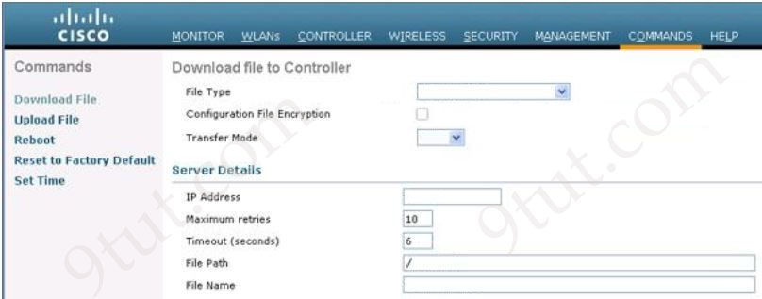
Which tasks must be performed on the Download File tab to install new software using TCP port 22?
A. Set the File Type to Code, set the Transfer Mode to SFTP, and specify the IP address of the WLC.
B. Set the File Type to Configuration, set the Transfer Mode to FTP, and specify the IP address of the file server.
C. Set the File Type to Code, set the Transfer Mode to SFTP, and specify the IP address of the file server.
D. Set the File Type to Configuration, set the Transfer Mode to SFTP, and specify the IP address of the WLC.

Answer: C
Explanation
SFTP uses port number 22 by default so we need to change “Transfer Mode” to SFTP.
From the reference below: Step 5. In the IP Address field, enter the IP address of the server. -> Answer C is correct.
Reference: https://www.cisco.com/c/en/us/td/docs/wireless/controller/8-10/config-guide/b_cg810/managing_configuration.html
Question 16.9
Which role do predictive AI models play in network load balancing?
A. They anticipate future traffic spikes.
B. They assign IP addresses to devices.
C. They select correct cabling types for deployment.
D. They solely monitor historical traffic volumes.

Answer: A
Explanation
Predictive AI aims to forecast future events or trends. It does this by analyzing historical data and identifying patterns -> Answer A is the best choice.
Question 16.10
Which AP mode wirelessly connects two separate network segments each set up within a different campus building?
A. mesh
B. local
C. bridge
D. point-to-point

Answer: C
Explanation
Bridge mode: bridge together the WLAN and the wired infrastructure together -> Answer C is not correct.
In Bridge Mode, Access Points are used to connect two networks. There are two sub modes coming with Bridge mode:
+ Point-to-Point: connect the LAN of a router to a remote access-point.
+ Point-to-Multipoint: connect two LANs with one wireless link
Therefore maybe this question implies about the Point-to-multipoint Bridge mode. But this option is not available so the best choice should be “bridge” mode.
Question 16.11
Which technology allows for logical Layer 3 separation on physical network equipment?
A. Virtual Switch System
B. Virtual Route Forwarding
C. IPsec Transport Mode
D. Time Division Multiplexer

Answer: B
Explanation
Virtual Routing and Forwarding (VRF) is a technology that logically partitions a single physical router into multiple virtual Layer 3 routers, each with its own independent routing table and forwarding instance.
Question 16.12
Which action prevents debug messages from being sent via syslog while allowing other messages when an abnormally high number of syslog messages are generated by a device with the debug process turned on?
A. Use an access list to filter out the syslog messages.
B. Turn off the logging monitor in global configuration mode.
C. Disable logging to the console.
D. Set the logging trap severity level to informational.

Answer: D
Explanation
The Syslog levels are:
Level | Keyword | Description
0 | emergencies | System is unusable
1 | alerts | Immediate action is needed
2 | critical | Critical conditions exist
3 | errors | Error conditions exist
4 | warnings | Warning conditions exist
5 | notification | Normal, but significant, conditions exist
6 | informational | Informational messages
7 | debugging | Debugging messages
Note: You can remember the order above with the sentence: “Eventually All Critical Errors Will Not Involve Damage”.
If you specify a level, that level and all the higher levels will be displayed. To change the minimum severity level that is sent to syslog, use the logging trap level configuration command.
Question 16.13
Which interface on the WLC is used exclusively as a DHCP relay?
A. distribution
B. service
C. AP-manager
D. virtual

Answer: D
Explanation
The virtual interface is used to manage and support wireless clients by providing DHCP relay functionality, guest web authentication, VPN termination and other services.
Reference: https://www.firewall.cx/cisco/cisco-wireless/cisco-wireless-controllers-interfaces-ports-functionality.html
Question 16.14
How is AI used to identify issues within network traffic?
A. It exclusively predicts device malfunctions.
B. It enhances data packet delivery speeds.
C. It simplifies traffic route mapping.
D. It analyzes patterns for anomaly detection.

Answer: D
Question 16.15
Why does an administrator choose to implement a remote access IPsec VPN?
A. to establish an encrypted tunnel between a remote user and a private network over the internet
B. to allow access to an enterprise network using any internet-enabled location via a web browser using SSL
C. to provide a secure link between an HTTPS server, authentication subsystem, and an end-user
D. to use cryptography for authentication between a device and user over a negotiated VPN gateway

Answer: A
Explanation
Remote access IPsec VPNs are used to provide secure, encrypted connections for individual users to a corporate network over the internet. They enable remote employees to access internal resources, such as servers, databases, and applications, from any location, extending the reach of the private network. This is achieved by establishing a secure IPsec tunnel, which uses encryption to protect data and authentication to verify the identity of users and devices.
Question 16.16
Which IP address is used when an administrator must open a web-based management session with a lightweight AP?
A. WLC IP
B. gateway IP
C. autonomous AP IP
D. ACS IP

Answer: A
Explanation
A lightweight access point (LAP) does not hold its own full management interface. Instead, it is managed centrally by the WLC. When an administrator wants to perform web-based management of a LAP, the connection must be made to the WLC’s IP address, not the AP itself.
Question 16.17
Which two principles must be considered when using per-hop behavior in QoS? (Choose two)
A. Policing is not supported on subinterfaces.
B. Shaping and rate limiting have the same effect.
C. Shaping drops excessive traffic without adding traffic delay.
D. Shaping levels out traffic bursts by delaying excess traffic.
E. Policing is performed in the inbound and outbound directions.

Answer: D E
Explanation
+ Policing: is used to control the rate of traffic flowing across an interface. During a bandwidth exceed (crossed the maximum configured rate), the excess traffic is generally dropped or remarked. The result of traffic policing is an output rate that appears as a saw-tooth with crests and troughs. Traffic policing can be applied to inbound and outbound interfaces. Unlike traffic shaping, QoS policing avoids delays due to queuing. Policing is configured in bytes.
+ Shaping: retains excess packets in a queue and then schedules the excess for later transmission over increments of time. When traffic reaches the maximum configured rate, additional packets are queued instead of being dropped to proceed later. Traffic shaping is applicable only on outbound interfaces as buffering and queuing happens only on outbound interfaces. Shaping is configured in bits per second.
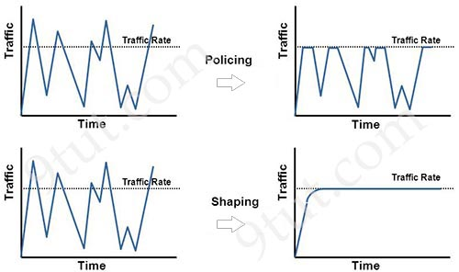
Question 16.18
What differentiates the TCP and UDP protocols?
A. TCP tracks segments being transmitted or received by assigning segment numbers, and UDP adjusts data flow according to network conditions.
B. TCP establishes a connection with the device on the other end before transferring, and UDP transfers without establishing a connection.
C. TCP sends data at a constant rate with error checking on upper protocol layers, and UDP provides error- checking and sequencing.
D. TCP immediately transmits data without waiting for a handshake, and UDP awaits a response from the receiver before sending additional data.

Answer: B
Question 16.19
What is a characteristic of an SSID in wireless networks?
A. provides protection against spyware
B. used to identify a Wireless LAN Controller
C. enables wireless clients to connect to a specific network
D. the password used to connect to an access point

Answer: C
Explanation
An SSID (Service Set Identifier) is the name of a wireless network that allows wireless clients to identify and connect to a specific WLAN. It’s broadcast by the access point so devices can see available networks. For example, when you open your phone’s Wi-Fi list and see names like “Home_WiFi” or “CoffeeShop_Free_WiFi”; those are SSIDs.
Answer B is not correct as the SSID identifies a wireless network, not a controller.
Answer D is not correct as SSID is the name, not the password of a wireless network.
Question 16.20
In which way does generative AI aid network simulations?
A. It computes optimal data storage solutions.
B. It creates synthetic network configurations.
C. It deploys network firmware updates.
D. It produce a greenfield network design.

Answer: B
Explanation
Generative AI for Network Configuration Generation
It’s not just monitoring, we need to deploy our changes as we need them and Generative AI models can be used to automatically generate network configurations based on specified requirements or our templates.
Reference: https://learningnetwork.cisco.com/s/question/0D56e0000Dp3UADCQ2/generative-ai-for-network-optimization
Question 16.21
Refer to the exhibit.
R1# show ip route
Codes: L - local, C - connected, S - static, R - RIP, O - OSPF, B - BGP
D - EIGRP, EX - EIGRP external, IA - OSPF inter area
N1 - OSPF NSSA external type 1, N2 - OSPF NSSA external type 2
E1 - OSPF external type 1, E2 - OSPF external type 2
i - IS-IS, su - IS-IS summary, L1 - IS-IS level-1, L2 - IS-IS level-2
ia - IS-IS inter area, * - candidate default, U - per-user static route
o - ODR, P - periodic downloaded static route

Gateway of last resort is not set

192.168.20.64/27 is variably subnetted, 1 subnet, 1 mask
O 192.168.20.64/27 [110/20] via 10.0.0.3, 00:00:01, Gig0/1
D 192.168.20.64/27 [90/25] via 10.0.0.4, 00:00:01, Gig0/2

192.168.20.96/28 is variably subnetted, 1 subnet, 1 mask
O 192.168.20.96/28 [110/30] via 10.0.0.3, 00:00:01, Gig0/1
D 192.168.20.96/28 [90/30] via 10.0.0.4, 00:00:01, Gig0/2

192.168.20.104/29 is variably subnetted, 1 subnet, 1 mask
O 192.168.20.104/29 [110/40] via 10.0.0.5, 00:00:01, Gig0/1
D 192.168.20.104/29 [90/40] via 10.0.0.6, 00:00:01, Gig0/2
A packet is destined for 192.168.20.108. Drag and drop the parameters of the destination route from the left onto the routing table components they represent on the right. Not all parameters are used.
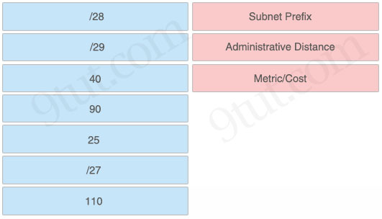

Answer:
/29: Subnet Prefix
90: Administrative Distance
40: Metric/Cost
Explanation
For destination 192.168.20.108, the local router will choose the last entry (D 192.168.20.104/29 [90/40] via 10.0.0.6, 00:00:01, Gig0/2) to match. Therefore /29 is the subnet prefix; 90 is the AD while 40 is the metric/cost of this route.
Question 16.22 (repeated)
Refer to the exhibit. What commands are needed to add a subinterface to Ethernet0/0 on R1 to allow for VLAN 20, with IP address 10.20.20.1/24?
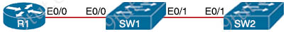
R1  interface Ethernet0/0  no ip address | SW1:  interface Ethernet0/0  switchport trunk encapsulation dot1q  switchport mode trunk  !  interface Ethernet0/1  switchport trunk allowed vlan 10  switchport trunk encapsulation dot1q  switchport mode trunk | SW2:  interface Ethernet0/1  switchport trunk encapsulation dot1q  switchport mode trunk  !  interface Ethernet0/2  switchport access vlan 20  switchport mode access
A. R1 (config)#interface ethernet0/0
R1 (config)#encapsulation dot1q 20
R1(config)#ip address 10.20.20.1 255.255.255.0
B. R1 (config)#interface ethernet0/0.20
R1 (config)#encapsulation dot1q 20
R1(config)#ip address 10.20.20.1 255.255.255.0
C. R1 (config)#interface ethernet0/0.20
R1(config)#ip address 10.20.20.1 255.255.255.0
D. R1 (config)#interface ethernet0/0
R1(config)#ip address 10.20.20.1 255.255.255.0

Answer: B
Question 16.23
What is a functionality of HSRP?
A. It provides router redundancy and route reconvergence when a router fails.
B. It enlists gratuitous ARP to update a client’s ARP cache when the active router switches over.
C. It requires active and standby routes to provide failover in the case of a router failure.
D. It uses virtual MAC addressing to provide gateway redundancy on a LAN.

Answer: D
Explanation
Answer A is not correct as HSRP provides gateway redundancy, not route reconvergence, which is a routing protocol function.
Answer B is not correct as gratuitous ARP is sent periodically, not when the active router switches over.
Answer C is not correct as HSRP does not have standby routes, only standby routers.
Answer D is correct as with HSRP, multiple routers share a virtual IP address and virtual MAC address.
Note: HSRP gratuitous ARP is a feature that configures a HSRP active router to periodically send gratuitous ARP packets. This ensures that switches and end hosts update their ARP and MAC address tables correctly when an HSRP failover occurs, allowing for a smoother transition of traffic.
Question 16.24
Refer to the exhibit.
MacOs$ ifconfig

en0: flags=8863<UP,BROADCAST,SMART,RUNNING,SIMPLEX,MULTICAST> mtu 1500
options=400<CHANNEL_IO>
ether f0:18:98:64:60:32
inet6 fe80::492:c09f:57cf:8c36%en0 prefixlen 64 secured scopeid 0x6
inet 10.8.138.14 netmask 0xffffe000 broadcast 10.8.159.255
nd6 options=201<PERFORMNUD,DAD>
media: autoselect
status: active
If the default gateway is the first usable IP address in the subnet, what is the default gateway?
A. 10.8.128.1
B. 10.8.132.1
C. 10.8.138.1
D. 10.8.144.1

Answer: A
Explanation
From the netmask 0xffffe000 (hexadecimal), we deduce the subnet mask is 255.255.224.0 as f (hexa) = 1111 (binary) while e (hexa) = 1110 (binary). Therefore for the 3rd octet it is e0 = 1110 0000 = 224 -> Increment: 32
The PC IP address is 10.8.138.14 so we can find the 3rd octect of this subnet is: 138 / 32 = 4 (only get the integer). And 32 * 4 = 128. Therefore the subnet is 10.8.128.0/19 -> The first usable IP address is 10.8.128.1.
Question 16.25
Refer to the exhibit.
R3#show ip route
Codes: L - local, C - connected, S - static, R - RIP, M - mobile, B - BGP, D - EIGRP, EX - EIGRP external, O - OSPF, IA - OSPF inter area,
N1 - OSPF NSSA external type 1, N2 - OSPF NSSA external type 2,
E1 - OSPF external type 1, E2 - OSPF external type 2, i - IS-IS,
su - IS-IS summary, L1 - IS-IS level-1, L2 - IS-IS level-2, ia - IS-IS
inter area, * - candidate default, I - per-user static route, o - ODR,
P - periodic download static route, H - NHRP, I - LISP,
a - application route, + - replicated route, % - next hop override,
p - overrides from PfR

Gateway of last resort is not set

10.0.0.0/8 is variably subnetted, 8 subnets, 4 masks
C 10.10.10.16/28 is directly connected, FastEthernet 0/0
L 10.10.10.17/32 is directly connected, FastEthernet 0/0
C 10.10.10.8/29 is directly connected, FastEthernet 0/1
L 10.10.10.9/32 is directly connected, FastEthernet 0/1
C 10.10.10.4/30 is directly connected, FastEthernet 0/2
L 10.10.10.5/32 is directly connected, FastEthernet 0/2
C 10.10.10.0/30 is directly connected, Serial 0/0
L 10.10.10.1/32 is directly connected, Serial 0/0
Which interface does a packet take to reach the destination address of 10.10.10.14?
A. Serial 0/0
B. FastEthernet 0/1
C. FastEthernet 0/0
D. FastEthernet 0/2

Answer: B
Explanation
The destination address of 10.10.10.14 matches entry “C 10.10.10.8/29 is directly connected, FastEthernet 0/1” so Fa0/1 is the exit-interface.
Question 16.26
Refer to the exhibit.
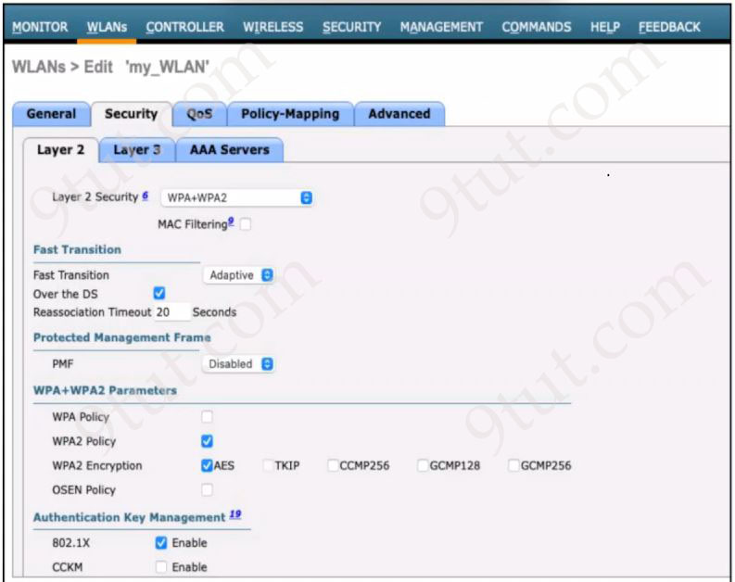
A network engineer is configuring a wireless LAN with Web Passthrough Layer 3 Web Policy. Which action must the engineer take to complete the configuration?
A. Enable the WPA Policy.
B. Set the Layer 2 Security to 802.1X.
C. Enable TKIP and CCMP256 WPA2 Encryption.
D. Set the Layer 2 Security to None.

Answer: D
Explanation
Cisco WLC’s Web Passthrough Layer 3 Web Policy is a guest access feature that redirects users to a policy page upon first connection, without requiring them to log in with credentials. Once the user accepts the policy, the WLC grants them full internet access.
Reference: https://www.cisco.com/c/en/us/support/docs/wireless-mobility/wireless-lan-wlan/116879-configure-wlc-00.html
Question 16.27
Drag and drop the characteristics from the left onto the corresponding protocol types on the right. Not all characteristics are used.
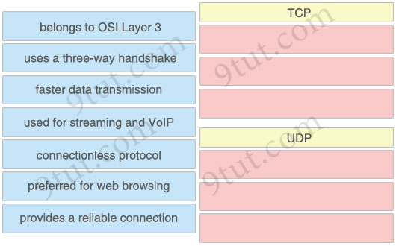

Answer:
TCP
+ uses a three-way handshake
+ preferred for web browsing
+ provides a reliable connection
UDP
+ faster data transmission
+ used for streaming and VoIP
+ connectionless protocol
Explanation
Both UDP & TCP belong to layer 4 (Transportation), not Layer 3.
Question 16.28
What is a characteristic of a Layer 2 switch?
A. transfers all frames received to every connected device
B. maintains stateful transaction information
C. offers link bundling to servers
D. transmits exclusively at half duplex

Answer: C
Explanation
Etherchannel can connect a switch to a host, as long as the host supports NIC teaming or link aggregation (LACP/static).
Question 16.29
What is represented in line 2 within this JSON schema?
1 [
2 {"switch": "SW_admin", "interface":"ge7/41"},
3 {"VPN concentrator": "VPN_finance", "interface":"fe9/5"},
4 {"IDS": "IPS_admin", "interface":"te2/10"},
5 ]
A. array
B. value
C. key
D. object

Answer: D
Explanation
Line 2 {"switch": "SW_admin", "interface":"ge7/41"} represents a JSON object, because it is enclosed in curly braces {} and contains key-value pairs.
Question 16.30
Drag and drop the IPv6 address from the left onto the type on the right.
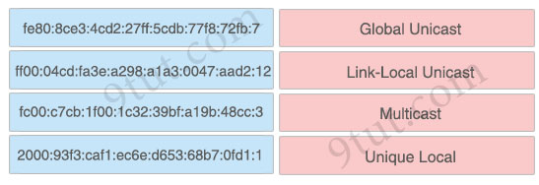

Answer:
+ Global unicast: 2000:93f3:caf1:ec6e:d653:68b7:0fd1:1
+ Link-Local unicast: fe80:8ce3:4cd2:27ff:5cdb:77f8:72fb:7
+ Multicast: ff00:04cd:fa3e:a298:a1a3:0047:aad2:12
+ Unique Local: fc00:c7cb:1f00:1c32:39bf:a19b:48cc:3
Explanation
Link-local addresses are allocated with the FE80::/64 prefix -> can be easily recognized by the prefix FE80
All IPv6 multicast addresses share the prefix of FF00::/8 -> The first octet is FF (1111 1111). This way you can tell at a glance if an IPv6 address is intended for multicast or not.
Unique local IPv6 addresses have the similar function as IPv4 private addresses. They are not allocated by an address registry and are not meant to be routed outside their domain. Unique local IPv6 addresses start with FC00::/7 -> The first octet can be FC or FD.
Question 16.31
What is a characteristic of private IPv4 addressing?
A. reduces the forwarding table on network routers
B. traverses the internet when an outbound ACL is applied
C. address space which is isolated from the internet
D. eliminates the need for routing between devices

Answer: C
Explanation
Private IPv4 addressing refers to IP addresses that are not routable on the public internet. These addresses are intended for use within internal networks; for example, in homes, offices, or enterprise LANs…
The Internet Assigned Numbers Authority (IANA) reserved specific ranges for private use:
+ 10.0.0.0 – 10.255.255.255 (10.0.0.0/8)
+ 172.16.0.0 – 172.31.255.255 (172.16.0.0/12)
+ 192.168.0.0 – 192.168.255.255 (192.168.0.0/16)
Because these addresses are isolated from the internet, they cannot be reached directly from public networks. To communicate externally, devices using private IPs typically rely on Network Address Translation (NAT), which converts private addresses to a public one for internet access.
Question 16.32
Which two HTTP verbs does a REST-based API call to create a resource? (Choose two)
A. GET
B. DELETE
C. POST
D. PUT
E. PATCH

Answer: C D
Explanation
In RESTful APIs, both POST and PUT can be used to create resources, depending on the situation:
– POST: Create a new resource under a collection
– Create or replace a specific resource at a known URI (client provides the ID). For example: PUT /users/123 creates user 123 if it doesn’t exist
Question 16.33
Refer to the exhibit.
R4#show ip route
Gateway of last resort is not set

10.0.0.0/8 is variably subnetted, 14 subnets, 2 masks
10.0.12.0/24 [100/2] via 10.0.24.2, 00:02:27, GigabitEthernet0/1
10.0.13.0/24 [90/3072] via 10.0.34.3, 00:00:19, GigabitEthernet0/0
10.0.24.0/24 is directly connected, GigabitEthernet0/1
10.0.24.4/32 is directly connected, GigabitEthernet0/1
10.0.34.0/24 is directly connected, GigabitEthernet0/0
10.0.34.4/32 is directly connected, GigabitEthernet0/0
10.0.45.0/24 is directly connected, GigabitEthernet0/2
10.0.45.4/32 is directly connected, GigabitEthernet0/2
10.2.0.0/24 [90/1] via 10.0.45.5, 00:00:08, GigabitEthernet0/2
10.255.1.1/32 [100/3] via 10.0.34.3, 00:02:27, GigabitEthernet0/0
[100/3] via 10.0.24.2, 00:02:27, GigabitEthernet0/1
10.255.2.2/32 [90/130816] via 10.0.24.2, 00:14:46, GigabitEthernet0/1
10.255.3.3/32 [100/2] via 10.0.34.3, 00:02:27, GigabitEthernet0/0
10.255.4.4/32 is directly connected, Loopback0
10.255.5.5/32 [90/1] via 10.0.45.5, 00:00:08, GigabitEthernet0/2
Considering default routing protocol configurations were used, which routing protocol is used to learn the 10.255.2.2/32 route?
A. EIGRP
B. BGP
C. RIP
D. OSPF

Answer: A
Explanation
The learned route “10.255.2.2/32 [90/130816] via 10.0.24.2, 00:14:46, GigabitEthernet0/1” has Administrative Distance of 90, which means EIGRP (default value).
Question 16.34
An application in the network is being scaled up from 300 servers to 600. Each server requires 3 network connections to support production, backup, and management traffic. Each connection resides on a different subnet. The router configuration for the production network must be configured first using a subnet in the 10.0.0.0/8 network. Which command must be configured on the interface of the router to accommodate the requirements and limit wasted IP address space?
A. ip address 10.10.10.1 255.255.255.240
B. ip address 10.10.10.1 255.255.240.0
C. ip address 10.10.10.1 255.255.254.0
D. ip address 10.10.10.1 255.255.252.0

Answer: D
Explanation
600 servers -> 600 connections for production (we don’t care about backup and management connections as “each connection resides on a different subnet”)-> 600 IP addresses in the same subnet. Therefore we need at least 210 = 1024 hosts/subnet (>600) -> We need 10 bit 0 in the subnet mask -> 11111111.11111111.1111 1100.0000 0000 -> 255.255.252.0 -> Answer D is correct.
Note: In fact, we need to subtract 2 from 210 for the host’s calculation but we ignored it because it does not affect the result.
Question 16.35
Which interface is used by an administrator to access the WLC GUI to update configuration settings?
A. management
B. service
C. dynamic
D. virtual

Answer: A
Explanation
The WLC uses the management interface to communicate with the access points, and we can use the management interface to configure the WLC through SSH or the GUI.
Question 16.36
A switch receives a frame with the destination MAC address 3C:5D:7E:9F:1A:2B.
Switch# show ethernet-frame-and-mac-address-table

Ethernet Frame:
+----------------------------------------------------+
| Destination MAC Address: 3C:5D:7E:9F:1A:2B |
| Source MAC Address: D3:F4:47:57:67:46 |
| EtherType/Length: 0x0800 (IPv4) |
| Payload: [Data] |
| Frame Check Sequence: [CRC] |
+----------------------------------------------------+
MAC Address Table:
VLAN MAC Address Type Ports
---- ----------------- -------- ----------
12 D3:F4:47:57:67:46 Dynamic Gi1/0/1
16 20:31:42:53:64:DE Static Gi1/0/2
24 A0:B3:C4:D3:B4:48 Secure Gi1/0/3
31 B5:16:32:12:6B:68 Dynamic Gi1/0/4
44 8F:A0:B3:C4:34:50 Static Gi1/0/5
How does the switch handle the frame?
A. It floods the frame to all ports except the incoming port.
B. It switches the frame to a predetermined port based on settings.
C. It ages out the frame until the MAC address becomes known.
D. It drops the frame to avoid unnecessary network congestion.

Answer: A
Explanation
We only care about the destination MAC address “3C:5D:7E:9F:1A:2B” and see that it has not been installed into the MAC address table. Therefore the switch will floods the frame to all ports except the incoming port.
Question 16.37
Which statement describes virtual machines?
A. They include a guest OS and the service.
B. They facilitate local management of infrastructure devices.
C. They use a supervisor to provide management for services.
D. They enable the network to become agile and hardware-centric.

Answer: A
Explanation
A virtual machine is a software-based emulation of a physical computer. It runs an operating system (guest OS) and applications (services) on top of a hypervisor, which manages multiple VMs on a single physical host.
Question 16.38
Which combination of methods satisfies the minimum security requirements when a new multifactor authentication solution is deployed?
A. password of 8 to 15 characters and personal 12-digit PIN
B. authorized USB dongle and mobile phone
C. complex password and time-based one-time password
D. fingerprint scanning and facial recognition

Answer: C
Explanation
Multifactor authentication (MFA) enhances security by requiring an additional authentication factor, such as:
+ Something you know (password or PIN…).
+ Something you have (a hardware token or mobile app…).
+ Something you are (biometric authentication like a fingerprint…).
Therefore the correct answer must have at least two different factors mentioned above.
Answer A is not correct as both of them are “something you know”
Answer B is not correct as both are “something you have”
Answer D is not correct as both are “something you are”
Answer C is correct as complex password is “something you know” and time-based one-time password means you have a mobile phone, which is “something you have”.
Question 16.39
Refer to the exhibit.
R4#show ip route
Gateway of last resort is not set

10.0.0.0/8 is variably subnetted, 14 subnets, 2 masks
O 10.0.12.0/24 [100/2] via 10.0.24.2, 00:02:27, GigabitEthernet0/1
D 10.0.13.0/24 [90/3072] via 10.0.34.3, 00:00:19, GigabitEthernet0/0
C 10.0.24.0/24 is directly connected, GigabitEthernet0/1
L 10.0.24.4/32 is directly connected, GigabitEthernet0/1
C 10.0.34.0/24 is directly connected, GigabitEthernet0/0
L 10.0.34.4/32 is directly connected, GigabitEthernet0/0
C 10.0.45.0/24 is directly connected, GigabitEthernet0/2
L 10.0.45.4/32 is directly connected, GigabitEthernet0/2
R 10.2.0.0/24 [120/1] via 10.0.45.5, 00:00:08, GigabitEthernet0/2
O 10.255.1.1/32 [100/3] via 10.0.34.3, 00:02:27, GigabitEthernet0/0
[100/3] via 10.0.24.2, 00:02:27, GigabitEthernet0/1
D 10.255.2.2/32 [90/130816] via 10.0.24.2, 00:01:46, GigabitEthernet0/1
O 10.255.3.3/32 [100/2] via 10.0.34.3, 00:02:27, GigabitEthernet0/0
C 10.255.4.4/32 is directly connected, Loopback0
R 10.255.5.5/32 [120/1] via 10.0.45.5, 00:00:08, GigabitEthernet0/2
Of the routes learned with dynamic routing protocols, which has the least preferred metric?
A. Local
B. EIGRP
C. OSPF
D. RIP

Answer: D
Explanation
The “metric” here is in fact the Administrative Distance (AD) of each dynamic routing protocol. RIP has an AD of 120, which is the least preferred metric of all above dynamic routing protocols.
Question 16.40
Refer to the exhibit.
R1#show ip route
Codes: L - local, C - connected, S - static, R - RIP, M - mobile, B - BGP,
D - EIGRP, EX - EIGRP external, O - OSPF, IA - OSPF inter area,
N1 - OSPF NSSA external type 1, N2 - OSPF NSSA external type 2,
E1 - OSPF external type 1, E2 - OSPF external type 2, i - IS-IS,
su - IS-IS summary, L1 - IS-IS level-1, L2 - IS-IS level-2,
ia - IS-IS inter area, * - candidate default, I - per-user static route,
o - ODR, P - periodic downloaded static route, H - NHRP, I - LISP, a -
application route, + - replicated route, % - next hop override,
p - overrides from PFR

Gateway of last resort is not set

10.0.0.0/8 is variably subnetted, 6 subnets, 2 masks
C 10.10.10.0/24 is directly connected, GigabitEthernet0/0
L 10.10.10.1/32 is directly connected, GigabitEthernet0/0
C 10.10.20.0/24 is directly connected, GigabitEthernet1/0
L 10.10.20.1/32 is directly connected, GigabitEthernet1/0
C 10.10.30.0/24 is directly connected, GigabitEthernet2/0
L 10.10.30.1/32 is directly connected, GigabitEthernet2/0

192.168.18.0/24 is variably subnetted, 3 subnets, 3 masks
D 192.168.18.0/24 [90/3072] via 10.10.10.10, 00:13:10, GigabitEthernet0/0
R 192.168.18.0/27 [120/1] via 10.10.20.10, 00:09:15, GigabitEthernet1/0
O 192.168.18.0/28 [110/2] via 10.10.30.10, 00:12:56, GigabitEthernet2/0
Which interface does a packet take to reach the host address of 192.168.18.16?
A. GigabitEthernet1/0
B. GigabitEthernet0/0
C. GigabitEthernet2/0
D. Null0

Answer: A
Explanation
For this question, surely 192.168.18.16 belongs to 192.168.18.0/24 prefix so we only need to check if it also belongs to another better prefix 192.168.18.0/27 or 192.168.18.0/28:
+ 192.168.18.0/28 – increment: 16 -> this prefix ranges from 192.168.18.0 to 192.168.18.15 so 192.168.18.16 does not belong to this prefix
+ 192.168.18.0/27 – increment: 32 -> this prefix ranges from 192.168.18.0 to 192.168.18.31 so 192.168.18.16 belongs to this prefix -> The exit interface for this prefix is GigabitEthernet1/0.
Question 16.41
Refer to the exhibit.
Prefix Interface Next-hop
152.168.32.0/22 f0/0 10.10.1.2
152.168.32.0/24 f1/0 10.10.2.2
152.168.32.0/26 f2/0 10.10.3.2
152.168.32.0/23 f3/0 10.10.4.2
Which next hop is used to route packets to the application server at 152.168.32.85?
A. 10.10.1.2
B. 10.10.2.2
C. 10.10.3.2
D. 10.10.4.2

Answer: B
Explanation
152.168.32.85 does not belong to 152.168.32.0/26 (increment: 64) and it belongs to 152.168.32.0/24 -> Next hop 10.10.2.2.
Note: If you are not sure how to find out the increment number, please read our Subnetting Tutorial – Subnetting Made Easy Tutorial (part 3)
Question 16.42
Refer to the exhibit.
R1#show ip route static
10.0.0.0/8 is variably subnetted, 3 subnets, 3 masks
S 10.20.1.0/26 [1/0] via 172.16.1.4
S 10.20.1.0/24 [1/0] via 172.16.1.2
S 10.20.1.32/27 [1/0] via 172.16.1.3
192.168.2.0/24 is variably subnetted, 3 subnets, 3 masks
S 192.168.2.0/24 [1/0] via 172.16.1.4
S 192.168.2.64/27 [1/0] via 172.16.1.2
S 192.168.2.80/29 [1/0] via 172.16.1.3
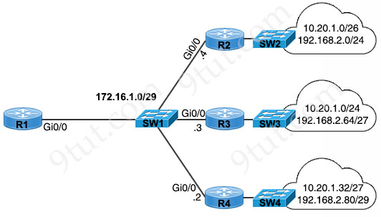
What is the correct next hop for router R1 to reach IP addresses 192.168.2.86 and 10.20.1.50?
A. 172.16.1.4
B. 172.16.1.1
C. 172.16.1.2
D. 172.16.1.3

Answer: C (?)
Explanation
The next-hops in the routing table and the topology are different so there is a typo in this question. The explanation below is based on the topology:
Among subnets 192.168.2.0/24, 192.168.2.64/27 and 192.168.2.80/29, packets destined to 192.168.2.86 will choose 192.168.2.80/29 (increment: 8) as it has longest prefix length and covers this destination.
In fact, above calculation is enough to find out the correct answer so we don’t need to calculate 10.20.1.50. Just for your information, 10.20.1.32/27 has increment of 32 so it also covers 10.20.1.50 destination.
Note: If we use the routing table and ignore the topology, answer D is the best choice.
Question 16.43
A default route must be configured to use the IP address of 192.168.1.1 until a WAN circuit is installed. The WAN circuit will use a dynamic routing protocol with an Administrative Distance of 20. Which configuration must be applied to allow the dynamic route to take precedence when it is in place?
A. ip route 0.0.0.0 0.0.0.0 192.168.1.1
B. ip route 0.0.0.0 0.0.0.0 192.168.1.1 25
C. ip route 0.0.0.0 0.0.0.0 192.168.1.1 track 1
D. ip route 0.0.0.0 0.0.0.0 192.168.1.1 20

Answer: B
Explanation
We must configure the default route with lower priority (higher value) than 20 so that BGP will be used when it is in place -> Answer B is correct with AD of 25.
Question 16.44
What is the main capability of multifactor authentication?
A. Identifying permissions for end users using three authentication factors
B. Authenticating and authorizing end users using two authentication factors
C. Confirming end-user identity using two or more authentication factors
D. Verifying end-user access permissions using two authentication factors

Answer: C
Explanation
MFA compose of 2 or more identifications
*Something you have
*Something you are
*Something you know
Question 16.45
Refer to the exhibit.
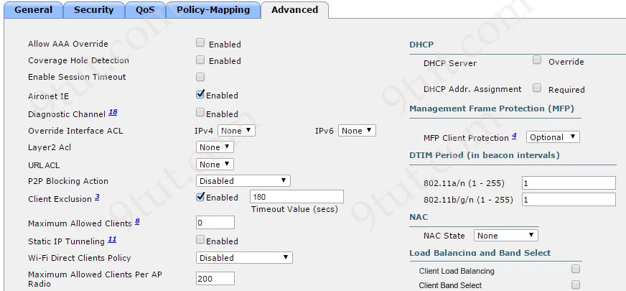
After a recent internal security audit, the network administrator decided to block all P2P-capable devices from the selected SSID. Which configuration setting must the administrator apply?
A. Set the P2P Block Action to Drop.
B. Select a correctly configured Layer 2 ACL.
C. Set the Wi-Fi Direct Client Policy to Not-Allow.
D. Set the MFP Client Protection to Required.

Answer: C
Explanation
Features | Purpose
P2P Blocking Action | Controls client-to-client communication within the same SSID through the AP (intra-BSS traffic). But it does not stop Wi-Fi Direct functionality specifically. It only stops communication through the AP, not direct device-to-device links.
Wi-Fi Direct Client Policy | Controls Wi-Fi Direct-capable devices (P2P devices) – that is, clients that can form a direct connection (device-to-device) without going through the access point.
-> Answer C is the best choice as it does not allow P2P-capable devices connect to the AP from the beginning.
Question 16.46
Which switch port configuration must be configured when connected to an AP running in FlexConnect mode, and the WLANs use flex local switching?
A. access port with one VLAN
B. trunk port with pruned VLANs
C. Layer 3 port with an IP address
D. tagged port with MAC Filtering enabled

Answer: B
Explanation
Prune VLANs for Flexconnect mode AP Switch Ports
For APs in Flexconnect mode, when using locally switched WLANs mapped to different VLANs (AP switch port is on trunk mode), prune or limit the VLANs present on the port to match the AP configured VLANs.
Reference: https://www.cisco.com/c/en/us/td/docs/wireless/controller/technotes/8-6/b_Cisco_Wireless_LAN_Controller_Configuration_Best_Practices.html
When an AP is running in FlexConnect mode, it can locally switch traffic at the remote site without tunneling all user data back to the WLC.
Note:
FlexConnect Local Switching means:
+ The AP locally bridges traffic onto the local VLAN at the branch site.
+ Each WLAN (SSID) can be mapped to a different VLAN on the local network -> The AP needs to support multiple VLANs for different SSIDs. Therefore, the switch port connected to the AP must be configured as a trunk port.
Question 16.47
What is a reason to implement HSRP on a network?
A. to ensure that user traffic in a LAN rapidly recovers from the failure of an edge routing device
B. to provide load balancing over multiple gateways in a LAN network
C. to optimally route traffic based on the forwarding capacity of the edge routing devices in the LAN network
D. to identify the closest hop to the default gateway in a LAN network

Answer: A
Explanation
Answer B is not correct as HSRP provides redundancy, not load balancing (though load sharing can be achieved by configuring multiple HSRP groups).
Answer C is not correct as it is a routing protocol function (like OSPF or EIGRP…), not HSRP.
Answer D is not correct as HSRP does not determine “closest” hops; it only provides a consistent default gateway via a virtual IP.
Answer A is correct as this is the primary purpose of HSRP: providing high availability and failover for the default gateway.
Question 16.48
Which feature is mandatory when configuring a new SSID for a wireless network running WPA3-Personal mode?
A. Opportunistic Wireless Encryption
B. Protected Management Frame
C. Enhanced Open
D. Fast Transition

Answer: B
Explanation
WPA3 Personal uses the Simultaneous Authentication of Equals (SAE) protocol with PMF required, replacing WPA2 Personal with Pre-shared Key (PSK).
Reference: https://docs.zebra.com/us/en/mobile-computers/software/bm-6ghz-for-cisco-wlan-best-practices-guide-ditamap/c-6ghz-security-recommendations-while-deploying-zebra-clients-in-6ghz-network/r-6ghz-wpa3-personal.html
In the figure below, we can see PMF is always “required” and cannot be changed.
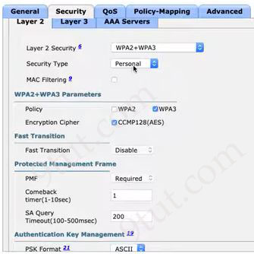
Note: Protected Management Frame (PMF) protects unicast and broadcast management frames and encrypts unicast management frames. This means wireless intrusion detection and wireless intrusion prevention systemsnow have fewer brute-force ways to enforce client policies.
Question 16.49
Refer to the exhibit.
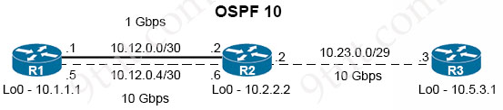
The loopback IP of R3 has been learned via the two interfaces on R1. R1 is configured with a reference bandwidth of 10 Gbps. Based on the metric calculations, which next hop IP would be used for outgoing routing?
A. 10.12.0.5
B. 10.12.0.2
C. 10.12.0.1
D. 10.12.0.6

Answer: D
Explanation
OSPF cost is calculated using the formula: Cost = Reference Bandwidth [Mpbs] / Interface Bandwidth [Mpbs].
“R1 is configured with a reference bandwidth of 10 Gbps”. Therefore the cost on each interface is calculated as follows:
+ Upper link: Cost = 10 / 1 = 10
+ Lower link: Cost = 10 / 10 = 1
-> The lower link has lower cost which is better -> R1 will choose the lower link for outgoing routing -> Answer D is correct.
Note: As both Reference Bandwidth & Interface Bandwidth use Gpbs, we don’t need to change from Gpbs to Mpbs in the calculation.
Question 16.50
Which feature of Digest Authentication prevents credentials from being sent in plaintext?
A. SSL/TLS encryption
B. Challenge-response mechanism
C. Token-based authorization
D. Public key infrastructure

Answer: B
Explanation
Digest authentication is a secure method for web servers to verify a user’s identity by using a challenge-response system to avoid sending plain-text passwords.
Here’s how it works:
1. The server sends a nonce (a random value) as a challenge to the client.
2. The client uses this nonce, along with the username, password, and other details, to generate a hash (typically MD5).
3. The client sends this hash to the server (not the plaintext password).
4. The server performs the same hash operation on its side and compares the results to authenticate the user.
Question 16.51
Which type of port configuration is used to carry traffic for multiple VLANs?
A. LAG
B. EtherChannel
C. trunk
D. access

Answer: C
Question 16.52
Refer to the exhibit.
R1#show ip route
S 192.168.64.0/18 [1/0] via 10.1.1.1
O 192.168.64.0/18 [110/236855] via 10.1.1.2
O 192.168.64.0/18 [110/229840] via 10.1.1.3
S 192.168.64.0/19 [1/0] via Null0
How will router R1 handle packets destined to 192.168.64.22?
A. It will use the static route to 10.1.1.1.
B. It will use the route with the highest AD and highest destination IP.
C. It will route the packets to 10.1.1.2.
D. It will drop the packets.

Answer: D
Explanation
192.168.64.0/19 subnet has increment of 32 so it ranges from 192.168.64.0 to 192.168.64.31 which covers destination of 192.168.64.22. Therefore traffic destined to 192.168.64.22 matches the output line “S 192.168.64.0/19 [1/0] via Null0” so it will be forwarded to Null0 interface, which means it will be dropped.
Note: A Null0 interface is a virtual “black hole” interface in a router that discards any traffic sent to it, and it’s primarily used to prevent routing loops, often when route summarization is configured. We can create above Null0 entry in the routing table with command “ip route 19.268.64.0 255.255.224.0 null0”.
Question 16.53
Which option in the port configuration of an Ethernet switch allows traffic from multiple VLANs to travel over the same physical link?
A. LAG
B. EtherChannel
C. trunk
D. access

Answer: C
Explanation
A “trunk” on a Cisco device is a point-to-point link between network devices, like switches, that carries traffic for multiple VLANs over a single physical connection. It uses the IEEE 802.1Q standard to tag frames with VLAN information, allowing them to be separated and routed correctly across the network.
Question 16.54
Refer to the exhibit.
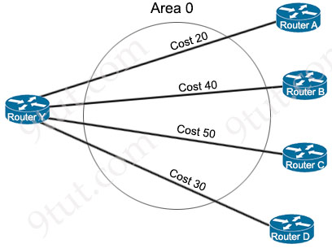
OSPF neighbors routers A, B, C, and D are sending a route for 10.227.150.160/27. When the current route for 10.227.150.160/27 becomes unavailable, which cost will router Y use to route traffic to 10.227.150.160/27?
A. Cost 20
B. Cost 30
C. Cost 40
D. Cost 50

Answer: B
Explanation
When a router learns multiple paths to a destination, it uses the cost to choose the most efficient route. The “cost” is the “price” of the path to reach the destination and the lower is the better. In this question the current (best) route has a cost of 20 so when it is unavailable, the path with cost 30 will be used instead.
Question 16.55
Refer to the exhibit.
AA#show ip route

10.0.0.0/8 is variably subnetted, 6 subnets, 2 masks
C 10.0.0.0/30 is directly connected, GigabitEthernet0/0
L 10.0.0.1/32 is directly connected, GigabitEthernet0/0
C 10.10.0.0/30 is directly connected, GigabitEthernet0/1
L 10.10.0.1/32 is directly connected, GigabitEthernet0/1
O 10.20.0.0/30 [110/2] via 10.0.0.2, 00:00:40, GigabitEthernet0/0
O 10.30.0.0/30 [110/2] via 10.0.0.2, 00:00:40, GigabitEthernet0/0
172.16.0.0/24 is subnetted, 1 subnets
S 172.16.10.0 [1/0] via 10.0.0.2
192.168.10.0/24 is variably subnetted, 2 subnets, 2 masks
C 192.168.10.0/24 is directly connected, GigabitEthernet0/2
L 192.168.10.1/32 is directly connected, GigabitEthernet0/2
S 192.168.20.0/24 [1/0] via 192.168.10.2
What is the administrative distance for the advertised prefix that includes the host IP address 192.168.20.1?
A. 0
B. 192.168.10.2
C. 24
D. 1

Answer: D
Explanation
The host IP address 192.168.20.1 is included in the last entry “S 192.168.20.0/24 [1/0] via 192.168.10.2”. This is a static route with AD of 1.
Question 16.56
Refer to the exhibit.
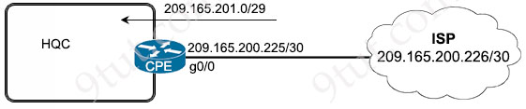
HQC needs to use a configuration that:
* Handles up to 150,000 concurrent connections
* Minimizes consumption of public IP addresses
Which configuration meets the requirements?
A. ip nat pool NATPOOL 209.165.201.1 209.165.201.5 netmask 255.255.255.248
ip nat inside source list HQC interface gigabitEthernet0/0 overload
B. ip nat pool NATPOOL 209.165.200.225 209.165.200.226 netmask 255.255.255.252
ip nat outside source list HQC pool NATPOOL overload
C. ip nat pool NATPOOL 209.165.201.1 209.165.201.3 netmask 255.255.255.248
ip nat inside source list HQC pool NATPOOL overload
D. ip nat pool NATPOOL 209.165.201.1 209.165.201.248 netmask 255.255.255.248
ip nat outside source list HQC pool NATPOOL overload

Answer: C
Explanation
A Cisco router using PAT can theoretically handle up to 64,511 ports per public IP address. These ports are generally in the 1024 to 65535 range to avoid conflicts with well-known ports (0-1023).
Therefore in order to “handles up to 150,000 concurrent connections”, we need 150,000/64,511 = 2.3. Also to “minimizes consumption of public IP addresses” -> We need a minimum of 3 public IP addresses -> The range “209.165.201.1 209.165.201.3” is the best choice.
Question 16.57
How are API keys used to enforce rate limiting?
A. To encrypt data sent in the API request
B. To define the network path the API request should take
C. To specify the type of data format the client prefers to receive
D. To uniquely identify each client application

Answer: D
Explanation
Rate limiting works by tracking how many requests each client makes. API keys uniquely identify each client, allowing the server to count their requests and enforce limits, such as 1,000 requests per day.
Question 16.58
Refer to the exhibit.
10.0.0.0/8 is variably subnetted, 15 subnets, 2 masks
O 10.0.12.0/24 [110/2] via 10.0.14.1, 00:17:46, GigabitEthernet0/2
C 10.0.14.0/24 is directly connected, GigabitEthernet0/2
L 10.0.14.4/32 is directly connected, GigabitEthernet0/2
O 10.0.23.0/24 [110/2] via 10.0.34.3, 00:17:46, GigabitEthernet0/0
C 10.0.34.0/24 is directly connected, GigabitEthernet0/0
L 10.0.34.4/32 is directly connected, GigabitEthernet0/0
C 10.0.45.0/24 is directly connected, GigabitEthernet0/1
L 10.0.45.4/32 is directly connected, GigabitEthernet0/1
O 10.0.254.1/32 [110/2] via 10.0.14.1, 00:17:46, GigabitEthernet0/2
R 10.255.2.4/24 [90/1] via 10.0.45.5, 00:00:13, GigabitEthernet0/1
O 10.255.1.1/32 [110/2] via 10.0.14.1, 00:17:46, GigabitEthernet0/0
O 10.255.2.2/32 [110/3] via 10.0.34.3, 00:17:46, GigabitEthernet0/0
[110/3] via 10.0.14.1, 00:17:46, GigabitEthernet0/2
O 10.255.3.3/32 [110/2] via 10.0.34.3, 00:17:46, GigabitEthernet0/0
C 10.255.3.4/32 is directly connected, Loopback0
R 10.255.5.5/32 [90/1] via 10.0.45.5, 00:00:13, GigabitEthernet0/1
Which routes are configured with their default administrative distances?
A. EIGRP
B. OSPF
C. RIP
D. Local

Answer: B
Explanation
The Administrative Distance (AD) of popular routing protocols is shown below. You should learn them by heart:
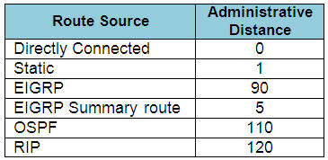
Note: The AD of iBGP is 200
From the table above, we see only OSPF is using its default AD of 110.
Question 16.59
Which security protocol is appropriate for a WPA3 implementation?
A. TKIP
B. GCMP
C. MD5
D. CCMP

Answer: B
Explanation
WPA3 uses GCMP (Galois/Counter Mode Protocol), typically GCMP-256, as its encryption and integrity protocol.
Note:
+ TKIP is legacy (WPA/WPA2) and not allowed in WPA3.
+ MD5 is a hashing algorithm, not an encryption protocol.
+ CCMP (AES-CCMP) is used in WPA2; WPA3 moves to stronger GCMP.
Question 16.60
Refer to the exhibit.
AccessSw1> show ntp associations
address ref clock st when poll reach delay offset disp
*~2001:DB8:12::1 127.127.1.1 3 39 64 377 23.903 -5.581 2.077
* sys.peer, # selected, + candidate, - outlyer, x falseticker, ~ configured
A network engineer must replicate the AccessSw1 NTP configuration on a new switch. The engineer could not access privileged mode on AccessSw1 to view its configuration. Which command must be applied to the new switch to replicate the configuration?
A. ntp server 2001:db8:12::1
B. ntp master 3
C. ntp master
D. ntp server 127.127.1.1

Answer: A
Explanation
– The address column shows the NTP server AccessSw1 is using: 2001:DB8:12::1.
– The ~ symbol indicates it is a configured server.
– The ref clock 127.127.1.1 shows the server’s own reference clock, not what AccessSw1 configured (127.127.1.1 = local clock on the NTP server)
Therefore, to replicate the same configuration on the new switch, you must configure the same NTP server that AccessSw1 is using, which is 2001:DB8:12::1.
Question 16.61
Which role does AI play in monitoring network data now?
A. It exclusively predicts device malfunctions.
B. It simplifies traffic route mapping.
C. It analyzes patterns anomaly detection.
D. It enhances data packet delivery speeds.

Answer: C
Explanation
AI contributes to network traffic analysis by examining patterns in network data to identify anomalies, which could indicate security threats, unusual activity, or performance issues. Machine learning algorithms can learn from historical network data to detect deviations from normal behavior, enabling proactive threat detection and response.
Question 16.62
What is a characteristic of a Layer 2 switch?
A. maintains stateful transaction information
B. prioritizes traffic using deep packet inspection
C. uses the data link layer for communications
D. provides a-single broadcast domain for all connected devices

Answer: C
Explanation
Pure Layer 2 switch (not Layer 3 switch) only communicates via the data link layer (Layer 2 of the OSI model) -> Answer C is correct.
Answer D is not correct as a switch can create VLANs which separate broadcast domains for connected devices.
Question 16.63
Which file transfer protocol omits a username or password requirement and acknowledges all data sent?
A. FTP
B. TFTP
C. SCP
D. SFTP

Answer: B
Explanation
TFTP (Trivial File Transfer Protocol) does not require a username or password and uses simple ACK (acknowledgment) messages for each block of data sent. It is designed to be lightweight and is commonly used for tasks like booting network devices or transferring configuration files.
Note for other protocols:
+ FTP: Requires username/password.
+ SCP & SFTP: Use SSH, require authentication.
Question 16.64
Refer to the exhibit.
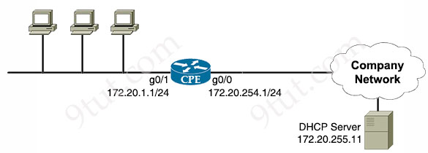
A network engineer must configure the CPE router to allow computers in the 172.20.1.0/24 network to obtain their IP configurations from the central DHCP server. Which configuration must the engineer apply to the CPE?
A. interface GigabitEthernet0/1
ip helper-address 172.20.255.11
B. interface GigabitEthernet0/0
ip helper-address 172.20.255.1
C. interface GigabitEthernet0/0
ip helper-address 172.20.1.1
D. interface GigabitEthernet0/1
ip helper-address 172.20.254.1

Answer: A
Explanation
If the DHCP Server is not on the same subnet with the DHCP Client, we need to configure the router on the DHCP client side to act as a DHCP Relay Agent so that it can forward DHCP messages between the DHCP Client & DHCP Server. To make a router a DHCP Relay Agent, simply put the “ip helper-address <IP-address-of-DHCP-Server>” command under the interface that receives the DHCP messages from the DHCP Client.
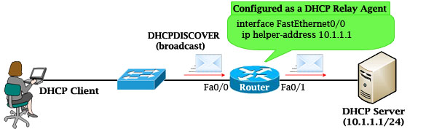
As we know, router does not forward broadcast packets (it drops them instead) so DHCP messages like DHCPDISCOVER message will be dropped. But with the “ip helper-address …” command, the router will accept that broadcast message and cover it into a unicast packet and forward it to the DHCP Server. The destination IP address of the unicast packet is taken from the “ip helper-address …” command.
Question 16.65
Refer to the exhibit.
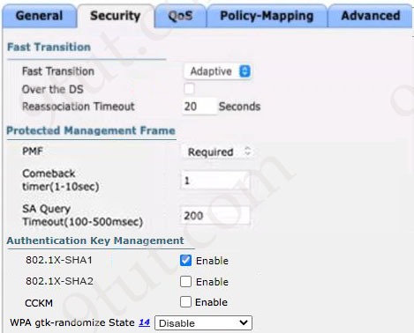
An engineer was asked to update a wireless LAN controller configuration on a newly deployed SSID “Office”. However, the configuration was not well documented or commented. What can the engineer determine about this configuration?
A. There is an additional protection level that helps secure the data frames exchanged between wireless clients and the access points for all wireless devices.
B. There is an extended delay that helps minimizing the time it takes for client devices to stay connected after roaming activity for Apple and Android devices.
C. There is an advanced secure algorithm put into the service to add an extra level of quality assurance for wireless delivery networks.
D. There is a seamless transition mechanism used to expedite roaming for compatible devices by authenticating them before potential roaming occurs.

Answer: D
Explanation
Protected Management Frame (PMF) protects unicast and broadcast management frames and encrypts unicast management frames. This means wireless intrusion detection and wireless intrusion prevention systems now have fewer brute-force ways to enforce client policies. PMF provides an additional layer of protection from de-authentication and disassociation attacks -> In the exhibit we see the “PMF” box was set to “Required” -> Answer A is not correct as PMF only protects management frames, not data frames.
Fast Transition (FT) is a new concept of roaming where the initial handshake with the new AP is done even before the client roams to the target AP. The initial handshake allows the client and APs to do the Pairwise Transient Key (PTK) calculation in advance. These PTK keys are applied to the client and AP after the client does the reassociation request or response exchange with new target AP -> Answer D is the best choice.
Note:
+ The comeback timer specifies the time that an associated client must wait before the association can be tried again when first denied with a status code 30.
+ SA query timeout specifies the amount of time the WLC waits for a response from the client for the query process. If there is no response from the client, its association is deleted from the controller.
Question 16.66
What is the difference between the TCP and UDP protocols?
A. TCP ensures ordered, reliable data delivery, and UDP offers low latency and high throughput.
B. TCP manages multicast and broadcast data transfers, and UDP only handles unicast communications.
C. TCP discovers neighboring devices on a local network segment, and UDP prevents Layer 2 switching loops.
D. TCP identities devices by their MAC addresses, and UDP identities devices by their IP addresses.

Answer: A
Explanation
In general, UDP offers higher potential throughput than TCP because its lack of overhead, flow control, and retransmission mechanisms allows it to “flood” available bandwidth, especially in the presence of latency or packet loss -> Answer A is correct.
Answer B is not correct as UDP also supports multicast & broadcast.
Answer C and answer D are not correct as they are not related to TCP & UDP.
Question 16.67
Refer to the exhibit.
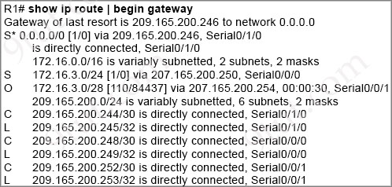
A packet is being sent across router R1 to host 172.16.0.14. To which destination does the router send the packet?
A. 209.165.200.246 via Serial0/1/0
B. 209.165.200.254 via Serial0/0/0
C. 209.165.200.254 via Serial0/0/1
D. 209.165.200.250 via Serial0/0/0

Answer: A
Explanation
IP 172.16.0.14 does not belong to 172.16.3.0/24 or 172.16.3.0/28 subnets so it will be routed via the default route.
Question 16.68
Refer to the exhibit.
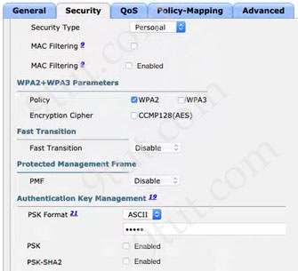
Users will be using a preconfigured secret key and SSID and must have a secured key hashing algorithm configured. The AAA server must not be used for the user authentication method. Which action completes the task?
A. Configure PSK-SHA2.
B. Configure PSK Format HEX with key string.
C. Set CCMP128(AES).
D. Enable AutoConfig iPSK.

Answer: A
Explanation
“must have a secured key hashing algorithm” -> choose SHA2 -> Answer A is correct.
Note: AES (Advanced Encryption Standard) is a symmetric encryption algorithm for confidentiality (encrypting/decrypting data to keep it secret), while SHA-2 (Secure Hash Algorithm 2) is a cryptographic hash function for integrity.
Question 16.69
Which two features are provided by Ansible in network automation? (Choose two)
A. supplies network credentials
B. pushes configurations to client
C. launches job templates using version control
D. uses YAML language
E. offers agentless deployment

Answer: D E (?)
Explanation
Ansible uses an agentless architecture to manage network devices. Agentless means that the managed device does not need any code (agent) to be installed on it. Therefore Ansible uses SSH (NETCONF over SSH in particular) to “push” changes and extract information to managed devices -> Answer B and answer E are correct.
Ansible playbooks are written in YAML, making them human-readable and easy to maintain -> Answer D is correct.
Therefore in fact we have three correct answers. But answer D and answer E are the most obvious ones so we should choose them.
Question 16.70
Which type of VPN connection is used when an employee accesses a secure server from a public Wi-Fi?
A. site-to-site
B. router-to-router
C. remote
D. open

Answer: C
Explanation
Remote-access VPN is used when an individual user (such as an employee) connects securely to a private network or server over an untrusted network like public Wi-Fi.
Remote access VPNs are often used by Internet Protocol security (IPSec) teams. Over less secure networks, such as public Wi-Fi, a VPN establishes a secure and encrypted connection. A VPN application both encrypts and decrypts the data you send and receive. It also encrypts the network IP addresses from which data is sent and received.
Reference: https://www.fortinet.com/resources/cyberglossary/remote-access-vpn
Question 16.71
What is the role of nonoverlapping channels in a wireless environment?
A. to reduce interference
B. to allow for channel bonding
C. to enable faster roaming
D. to increase bandwidth

Answer: A
Explanation
The goal of using different non-overlapping channels is to avoid the affects caused by channel utilization and interference.
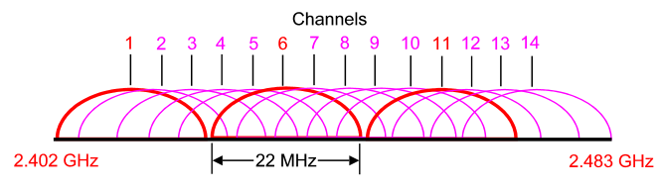
The 2.4 GHz band is subdivided into multiple channels each allotted 22 MHz bandwidth and separated from the next channel by 5 MHz.
-> A best practice for 802.11b/g/n WLANs requiring multiple APs is to use non-overlapping channels such as 1, 6, and 11.
When two wireless devices transmit at the same time, their radio signals will collide and become garbled. 802.11 devices on the same channel use a CCA check to avoid these collisions. However, the CCA check may not detect a transmission occurring on a different channel that also has some frequency overlap on the channel the check is being performed on. In this case, two 802.11 devices on different channels that overlap may transmit at the same time causing a collision and possible data corruption or frame loss. This is called interference because one device’s transmission interferes with another device’s transmission.
Reference: https://documentation.meraki.com/Wireless/Design_and_Configure/Architecture_and_Best_Practices/Channel_Planning_Best_Practices
Question 16.72
What is represented in line 3 within this JSON schema?
1 [
2 {"switch": "SW_dallas", "port":"ge16"},
3 {"load balancer": "LB_munich", "port":"te8/26"},
4 {"VPN concentrator": "VPN_toronto", "port":"te8/15"},
5 ]
A. array
B. value
C. key
D. object

Answer: D
Explanation
Line 2 {"load balancer": "LB_munich", "port":"te8/26"} represents a JSON object, because it is enclosed in curly braces {} and contains key-value pairs.
Question 16.73
Which security program element helps protect against employees unintentionally leaking sensitive information via email?
A. workstation screen recordings
B. user awareness campaigns
C. controlled internet access
D. physical access controls

Answer: B
Explanation
User awareness campaigns train employees to recognize sensitive information, understand data handling policies, and avoid mistakes such as sending confidential data to the wrong recipient or falling for phishing emails.
Question 16.74
What is the purpose of the logging facility?
A. It indicates the program or process that generated the syslog event.
B. It contains the text message that describes the syslog event.
C. It defines the severity of the syslog event.
D. It represents the timestamp of the syslog event.

Answer: A
Explanation
A syslog message has the following format:
seq no:timestamp%FACILTY-SEVERITY-MNEMONIC: message text
Example: Jul 10 14:32:18.456: %LINK-3-UPDOWN: Interface GigabitEthernet0/1, changed state to down
Each portion of a syslog message has a specific meaning. In which the FACILITY tells the protocol, module, or process that generated the message. Some examples are SYS for the operating system, IF for an interface…
All syslog messages have a logging facility and a level. The logging facility can be thought of as where and the level can be thought of as what.
Reference: https://www.cisco.com/en/US/docs/storage/san_switches/mds9000/sw/rel_1_x/1_1_1a/san-os/configuration/guide/Logging.pdf
In the example above, the Facility: LINK means interface/link-related events on Cisco devices.
Question 16.75
Which AP mode provides a wireless connection between two network segments?
A. root
B. local
C. FlexConnect
D. bridge

Answer: D
Explanation
Bridge mode: Access Points are used to connect two networks. There are two sub modes coming with Bridge mode:
+ Point-to-Point: connect the LAN of a router to a remote access-point.
+ Point-to-Multipoint: connect two LANs with one wireless link.
Question 16.76
What is the purpose of a CNAME record?
A. to associate an alias to a canonical domain name
B. to map a domain name to an IP address
C. to identify the authoritative name server for a domain
D. to direct email to a mail server

Answer: A
Explanation
A CNAME (Canonical Name) record is used to create an alias that points to the true (canonical) domain name. This allows multiple domain names to refer to the same host. For example:
example.com (apex domain) -> has an A record pointing directly to your server’s IP address (e.g., 192.0.2.1).
www.example.com (subdomain) -> has a CNAME record pointing to example.com.
When someone visits www.example.com:
1. DNS looks up the CNAME record and sees that www.example.com points to example.com.
2. It checks the records for example.com.
3. The A record for example.com provides the IP address of the server.
4. The user is connected to the same destination as if they had typed example.com.
Question 16.77
Refer to the exhibit.
ip route 172.0.0.0 255.0.0.0 10.12.13.14
ip route 172.16.0.0 255.255.0.0 10.56.22.23
ip route 122.16.153.0 255.255.255.0 10.35.47.17
ip route 172.16.153.153 255.255.255.255 10.65.34.19
ip route 0.0.0.0 0.0.0.0 10.17.44.36
The static routes were implemented on the border router. What is the next hop IP address for a ping sent to 172.16.153.154 from the border router?
A. 10.35.47.17
B. 10.65.34.19
C. 10.12.13.14
D. 10.56.22.23

Answer: D
Explanation
The best match for the destination 172.16.153.154 is “ip route 172.16.0.0 255.255.0.0 10.56.22.23” so answer D is correct. If we don’t look each statement carefully, we may choose “ip route 122.16.153.0 255.255.255.0 …” by mistake (here is 122, not 172).
Question 16.78
Which cable type must be used when connecting a router and switch together?
A. console
B. rollover
C. straight-through
D. crossover

Answer: C
Explanation
To remember which type of cable you should use, follow these tips:
– To connect two serial interfaces of 2 routers we use serial cable
– To specify when we use crossover cable or straight-through cable, we should remember:
Group 1: Router, Host, Server
Group 2: Hub, Switch
One device in group 1 + One device in group 2: use straight-through cable
Two devices in the same group: use crossover cable
For example: we use straight-through cable to connect switch to router, switch to host, hub to host, hub to server… and we use crossover cable to connect switch to switch, switch to hub, router to router, host to host… )

